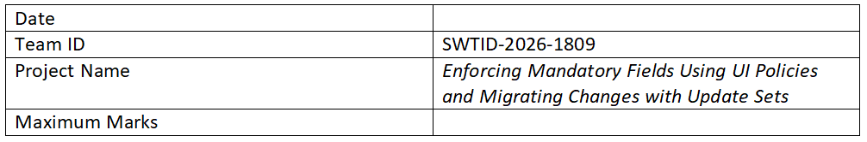

Project Planning Phase
Date: 15 February 2025
Team ID:
Project Name: Enforcing Mandatory Fields Using UI Policies and Migrating Changes with Update Sets
Maximum Marks: 5 Marks

Product Backlog, Sprint Schedule, and Estimation
Sprint | Functional Requirement (Epic) | User Story Number | User Story / Task | Story Points | Priority | Team Members
Sprint-1 | UI Policy Creation | USN-1 | Create UI policies to enforce mandatory fields | 3 | High
Sprint-1 | UI Policy Creation | USN-2 | Define conditions for mandatory fields | 2 | High
Sprint-1 | UI Policy Testing | USN-3 | Verify mandatory fields appear correctly | 2 | Medium
Sprint-2 | UI Policy Actions | USN-4 | Configure UI policy actions | 3 | High
Sprint-2 | Update Sets | USN-5 | Create update sets | 2 | High
Sprint-2 | Update Sets | USN-6 | Migrate update sets | 3 | High
Sprint-3 | Testing | USN-7 | Validate UI policies | 2 | Medium
Sprint-3 | Migration Validation | USN-8 | Verify migrated changes | 2 | High
Sprint-4 | Documentation | USN-9 | Prepare documentation | 1 | Low
Sprint-4 | Deployment | USN-10 | Deploy to production | 2 | High

Project Tracker, Velocity & Burndown Chart
Sprint | Total Story Points | Duration | Start Date | End Date | Completed | Release Date
Sprint-1 | 10 | 5 Days | 01 Mar 2025 | 05 Mar 2025 | 10 | 05 Mar 2025
Sprint-2 | 10 | 5 Days | 07 Mar 2025 | 11 Mar 2025 | 10 | 11 Mar 2025
Sprint-3 | 10 | 5 Days | 13 Mar 2025 | 17 Mar 2025 | 10 | 17 Mar 2025
Sprint-4 | 10 | 5 Days | 19 Mar 2025 | 23 Mar 2025 | 10 | 23 Mar 2025

Velocity
Velocity = 10 story points / 5 days = 2 story points per day

Burndown Chart
Represents remaining work vs time.

